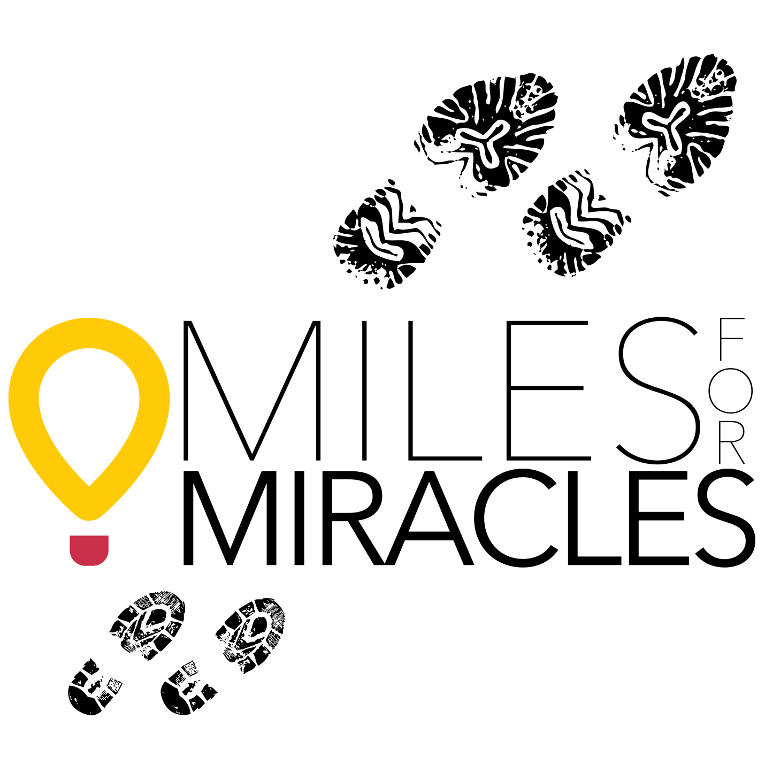

FUNDRAISING TOOLKIT
Miles For Miracles is an official charity running team of the 2015 GO! St. Louis Marathon & Family Fitness Weekend

QUESTIONS?
Contact Children’s Miracle Network Hospitals’ Project Coordinator, Brooke Adams at badams@cmn-stl.org or 314.577.5318.

INTRODUCTORY COMMENTS
This fundraising toolkit can be used to help you (the runner) raise money for Children’s Miracle Network Hospitals of Greater St. Louis. Fundraising is not limited to the ideas noted in this tool kit . . . the sky’s the limit! The key to fundraising is to be creative, think outside the box, and when in doubt . . . ASK!

Often times, people shy away from asking others to donate because fund-raisers feel as if they are asking for money for themselves. Remember that you are simply offering others an opportunity to donate to Children’s Miracle Network Hospitals of Greater St. Louis so that sick and injured children can have a better quality of life. If they say “no” then make the offer to someone else. Don’t forget to brush up on your Children’s Miracle Network Hospitals facts so that you can adequately explain to potential donors how their donation makes a difference in a child’s life. Please see the Official Facts and Figures sheet on page 5.

FUNDRAISING IDEAS

EMAIL and LETTER-WRITING CAMPAIGN
This is the most common and widely used approach. This also provides the most comprehensive information and materials for your potential donor and makes it easy for them to donate online.

Letter Content
See page 4 for a sample letter. Use the sample as a guide and edit the letter to fit your personality and audience; if you prefer, create your own letter. Don’t forget to include the link to your personal donor web page and remind people that it is a secure link and their credit card information will be safe.

The following are important points to make in verbal or written communications:
- Include a picture or video message of yourself; this helps the donor make a personal connection to the cause.
- Use your Donor Drive personal fundraising web page to send a pre-populated email message to your potential donors. If you really feel ambitious use a free and easy email server like mailchimp.com to help you design an eye-catching email.
- Ask for contributions, not pledges, since you need to collect the donations up front.
- All contributions are tax 100% tax deductible
- Suggest to the donor that they check if their company matches employee contributions. Have them send the company’s matching gift form with their donation and we’ll facilitate the rest. This is an easy way to maximize your donations and for the donor to feel like they are doubling their contribution.
- Your friends may not have $100 to give, but a business may be able to give $100 or much more. Know your audience and customize your letters and requests for donations accordingly.

Checks
If you feel that your prospective donor is uncomfortable making an online donation have them write a check. All checks should be made payable to Children’s Miracle Network Hospitals with a memo line of Miles For Miracles and the runner’s name. Make sure your name is also on the check so that we can add it to your personal fundraising goal. All checks should be mailed to Children’s Miracle Network Hospitals, C/O Miles For Miracles, 5700 Oakland Avenue, Suite 220, St. Louis, MO 63110.

SOCIAL MEDIA
Many people get a large response by posting their fundraising page on social media sites such as Twitter, Facebook, Google+…etc. You can tag friends who you think might support you or help get the information out to other friends. You can also send personal messages to friends or post to groups who might also be interested.

Tips on Using Social Media
Social media allows you to share your story, the Miracle Children’s stories, and the unique reasons you have for running in an immediate and very personal way. “Like” Children’s Miracle Network of Greater St. Louis on Facebook https://www.facebook.com/#!/CMNstl and friend us on Twitter https://twitter.com/CMNstl.
- Post your story on Facebook with relevant pictures to help promote your involvement with Children’s Miracle Network Hospitals of Greater St. Louis through the Miles for Miracles program.
- Don’t create your own Facebook page. This confuses Facebook users. Instead, refer everyone to your personal fundraising race page and the Miles For Miracles web page. http://www.helpmakemiracles.org/index.cfm?fuseaction=donordrive.event&eventID=1732
- When posting on Twitter include our @CMNstl handle.
- If you’re real tech-savvy create a quick video with a smart phone of you doing a verbal ask and post it to your Facebook. Ask your friends to “share” the video to “help you, help the kids”.

CANNING AT YOUR LOCAL GROCERY STORE
This is an easy way to quickly meet your goal. All you have to do is stand outside of your local grocery store (or any store with high traffic) and let shoppers know that you are raising money to help improve the lives of children here in St. Louis. The generosity of your fellow St. Louisans will amaze you. To do this you need to speak to the manager of your local store to secure a date and time. Ask the manager if the store has a day of the week and/or time of day that is busier than others; plan your event accordingly.

OFFICE EVENT
Check with your company regarding distribution of flyers and e-mails, and posting posters on the office bulletin board. Bring a dessert and host a brief gathering after lunch. Set up a fundraising table with Miles for Miracles information in your cafeteria or employee lounge.

PARTY
Now you have a reason to plan a party! Host a gathering by yourself or with other runners. Make it interesting by announcing a theme party (i.e., Happy Hour, dessert, or pasta party). Take a brief moment, either as a group or one-on-one and let people know about your marathon and fundraising goals and ask for their support.

SHARE YOUR TALENTS
Do you have a marketable talent or skill? Offer your services for a donation to your fundraising campaign.

CORPORATE MATCHING
Many corporations offer a Matching Gift Program. Inquire if your company/organization has a program to match your charitable giving. You may want to set a date by which we’ll verify you have raised a certain amount, and then submit that for matching. (Since the process can take some time, you should look at this as bonus funds in addition to your goal and not a part of that initial total.) It adds to your results with very little effort. You should also ask your Donors if they have matching gift programs through their employers to match their own contributions. Donors should email the matching gift form to badams@cmn-stl.org with their contribution and we’ll process it as directed.

COLLECTING DONATIONS

WHO SHOULD I ASK?
Start with the people you know best . . . your family, friends, business colleagues . . .
The key is: ALL YOU HAVE TO DO IS ASK! You’ll be glad to find that people are more than happy to contribute.

FOR HOW MUCH DO I ASK?
You know your audience and of what level giving each person may be capable. Don’t
Underestimate, because you might get surprised by your donor’s generosity…but don’t scare someone off either. The bottom line is that every little bit helps.

THANKING YOUR DONORS
Once race weekend is complete, it would be a nice gesture on your part to send a personalized letter of thanks. Perhaps you can share your marathon experience with those who helped support you along the way. Let us know if you would like a sample thank you letter.

SAMPLE LETTER

Dear friends,

I am a member of Miles for Miracles, a group of runners committed to raising funds for Children's Miracle Network Hospitals of Greater St. Louis. Over the next few months I will put in many hours of training for the GO! St. Louis Marathon; in addition to my training, I am raising funds to ensure that sick kids in the greater St. Louis area get the care they need. I hope that you will consider supporting my participation in Miles for Miracles! Funds raised will stay in our community, benefiting our two Children's Miracle Network Hospitals – St. Louis Children's Hospital and SSM Cardinal Glennon Children's Medical Center. These hospitals treat more than 450,000 kids each year, and they use the funds raised to acquire new patient programs, equipment, and facility renovations. In past years, Children's Miracle Network Hospitals of Greater St. Louis has helped fund Child Life programs at both hospitals, the Bob Costas Cancer Center at SSM Cardinal Glennon Children's Medical Center, and the Neonatal Intensive Care Unit at St. Louis Children's Hospital. Each and every donation is appreciated and directly benefits the kids and their families! Donating online is safe and easy, and all donations are tax deductible. To make an online donation, please use the "Support This Participant" button on this page. If you prefer to donate with a check or cash, please contact me to arrange that as well. Thank you for visiting my fundraising page and helping me make a difference in the lives of local kids. If you're in the St. Louis area the weekend of April 11-12, 2015, I encourage you to come cheer on the Miles for Miracles team at the GO! St. Louis Marathon and Family Fitness Weekend.

Sincerely,
Your Name

2013 Official Facts & Figures

General Facts*
- Children's Miracle Network Hospitals raises funds and awareness for 170 children's hospitals in North America.
- 62 children enter a Children’s Miracle Network Hospital for treatment every minute.
- 1 in 10 kids in North America is treated by Children’s Miracle Network Hospitals each year.
- Children's Miracle Network Hospitals provide 32 million patient visits for 10 million kids every year.
- In 2012, Children’s Miracle Network Hospitals raised more than $290 million for local children’s hospitals.
- Since 1983, Children's Miracle Network Hospitals has raised $4.7 billion, most of it a dollar at a time. Local children's hospitals use the funds however they need them most.
  - *Entire Network

Treatment Facts*
- Every day, Children’s Miracle Network Hospitals treat:
  - 16,000 kids in the ER
  - 935 kids for diabetes
  - 2,218 kids for cancer
  - 925 babies in the newborn ICU
  - 2,329 kids for surgeries
- Every hour, Children’s Miracle Network Hospitals treat:
  - 675 kids in the ER
  - 39 kids for diabetes
  - 92 kids for cancer
  - 39 babies in the newborn ICU
  - 97 kids for surgeries
*Entire Network

Charity Care Facts*
- Every minute, Children’s Miracle Network Hospitals provide $6,500 in charity care to help save kids’ lives.
- Children’s Miracle Network Hospitals’ members provided $3.4 billion in charity care in 2012.
*U.S. Hospitals Only

