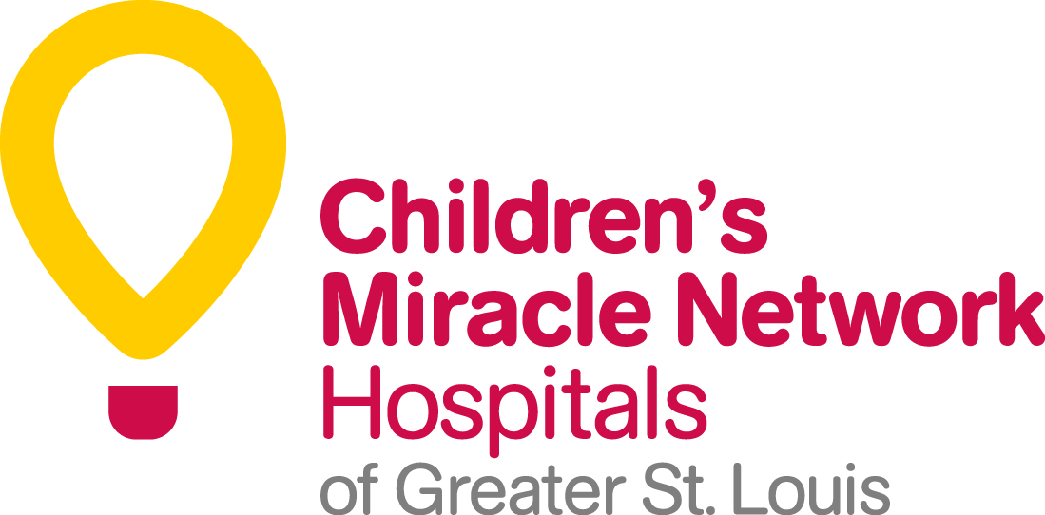
Miles for Miracles Team
Commitment Form
GO! St. Louis Marathon & Family Fitness Weekend
April 11 & 12, 2015

Thank you for joining the Miles for Miracles Team. By joining our team, you are committing to raising funds and awareness for Children’s Miracle Network Hospitals of Greater St. Louis, money that will be used to help our member hospitals acquire new patient programs, equipment, and facility renovations. You are making a tremendous difference in the lives of the more than 450,000 kids treated each year at St. Louis Children’s Hospital and SSM Cardinal Glennon Children’s Medical Center. Our staff is committed to ensuring all participants meet their fundraising minimum and will provide tools for success.

Name____________________________________________ Company/Group Name:___________________________________

Participation options – please circle one (If you select Relay Team, you must submit all four Relay Team commitment forms together)

Marathon | Half Marathon | Relay Team | 5K
$750 minimum | $500 minimum | $1260/$315 pp minimum | $150 minimum

Address ____________________________________________________City/State/Zip __________________________________
Phone ( )________________________________Email________________________________________________________
Sex | M | F | Shirt Size | S | M | L | XL | 2XL | 3XL

Birth date ____/____/____(Runners/walkers must be at least 14 years old on race day)
Benefits of joining the Miles for Miracles Team
- Quick, easy, and FREE online registration (until March 16, 2015)
- Personal web page for convenient online fundraising
- Two (2) technical shirts (one each from GO! St. Louis and from the Miles for Miracles Team)
- Free 12-week training program with Big River Running and the Miles for Miracles Team
- Special guided tours of the two benefiting hospitals
- Pre-event pasta party with Children’s Miracle Network Hospitals Miracle Families
- Access to Miles for Miracles Team race day tent and amenities
- Regular newsletters – tips, encouragement, Miracle Kids stories, etc.
- Fundraising toolkit to ensure you can meet your goal
- The great feeling from helping sick and injured kids in the St. Louis area!

TERMS & CONDITIONS: All runners/walkers who are participating on the Miles for Miracles Team are expected to raise the minimum required amount for their race ($750-Marathon, $500-Half Marathon, $1260/$315pp-Marathon Relay, $150-5K). By signing this commitment form you are committing to raise this amount for Children’s Miracle Network Hospitals of Greater St. Louis and the sick kids in our area. A valid credit card (MasterCard, Visa, Discover or American Express) in your name and valid through April 2014 must be provided. On April 1, 2014, the credit card will be charged for any balance due to reach the fundraising minimum.

PARTICIPANT COMMITMENT: I understand that I am responsible for meeting the fundraising minimum for the GO! St. Louis race I selected. I further understand that should I fail to raise enough funds by April 1, 2014, the credit card I have provided below will be charged for the balance due.

I’d like to make the first donation to my fundraising efforts: $25 $50 $75 Other $______________

Name as it appears on the card _____________________________________________________________________________
Credit Card Number _____________________________________________ Exp. Date ___________Security Code________
Signature ______________________________________________________________ Date ______________________________
Please complete this form and return it to Children’s Miracle Network Hospitals of Greater St. Louis, ATTN: Brooke Adams.
5700 Oakland Ave. | Suite 220 | St. Louis, MO 63110 | badams@cmn-stl.org

